C/C++ EXTRA CREDIT LAB REPORT

1) Enter your name, student ID, platform (Mac or PC) and date
Name: Jay Gupta
Class: CIS054 C/C++ Programming
Platform (Mac or PC): PC
Date: 5/3/2020

DESCRIPTION:
Choose either the Tortoise and the Hare Simulation lab or the Two-dimensional Array Sales Summary lab for extra credit lab project. These projects are in the C++ How to Program online textbook that is free to borrow from Vital Source. Instructions on how to get the textbook are included in the Week 11 Announcements. You can enter a specific page in the box on the lower left side when displaying pages from the textbook.
The Tortoise and the Hare Simulation is exercise 8.12 in the C++ How to Program online textbook on page 374. You can select a page in the textbook. The one-second timer is simulated by each pass through a loop.
The Two-dimensional Array Sales Summary is exercise 7.21 in the C++ How to Program online textbook on page 331.
DISCUSSION:
2) Complete the DISCUSSION section. It does not need to be long, but it needs to be complete.
2a) What did you do to develop the program? ("Followed the Directions" is not a complete description)

I first created the function declarations, breaking the program into pieces. Then, I programmed each function, unit-testing it. I debugged when I had problems by consulting Google and other sources.

2b) What problems did you have and how did you overcome the problems?

I had a few problems concerning the dashes, mainly because they weren’t exactly lining up with the length of the race. I overcame the problems by debugging; I tested the program until it met my needs.

PROGRAM OUTPUT:
3) Show screen shots of the program execution.
Refer to previous lab assignments for instructions on how to capture a screen or portions of a screen for either the PC or a Mac

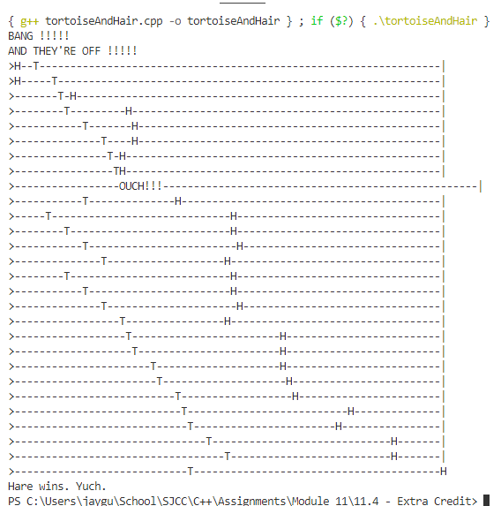

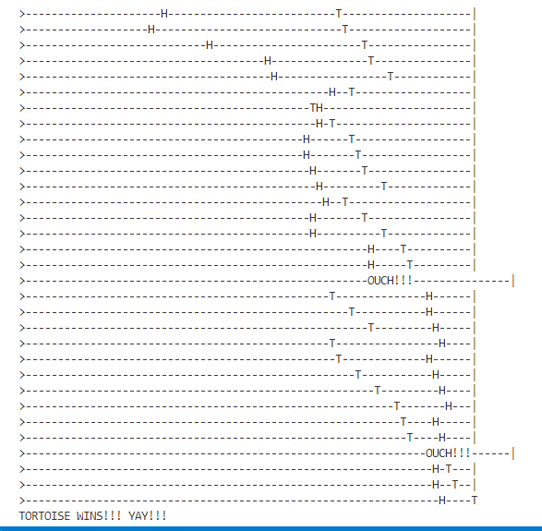

PROGRAM LISTING:
4) Copy and paste the code that YOU typed to make the program work. Your program should include a comment block at the top that shows the name of the program, date, version and your name.

/**
* Name: Jay Gupta
* Class: CIS 054 C/C++ Programming
* File & Version: tortoiseAndHair.cpp (V1.0)
* Extra Credit
* Inputs: None
* Outputs: race between tortoise and hair. Who won, or if there is a tie.
* Date: 5/3/2020
*/

/*
t and h begin at square 1
square 70 is finish line
first to reach/pass 70 is winner
clock that ticks once per second
each tick (second), use functions moveTortoise and moveHare
USE POINTER BASED PASS-BY-REFERENCE to modify positions
Figure 8.18 shows movement types, percentages, and number of squares
use variables to keep track of positions of animals
if animal slips left before square 1, move animal back to square 1
*/

#include <iostream>
#include <ctime>
using namespace std;

void moveTortoise(int *positionOfTortoise);
void moveHare(int *positionOfHare);
void displayCurrentStatus(int *harePosition, int *tortoisePosition);

const int lengthOfRace = 70;

int main() {
// beginning of the race
cout << "BANG !!!!!" << endl;
cout << "AND THEY'RE OFF !!!!!" << endl;

// initial variables
int tortoisePosition = 1;
int harePosition = 1;
srand(time(0)); // initialize random seed, for use in random-number generation

// while no one has won the race...
while (tortoisePosition < lengthOfRace && harePosition < lengthOfRace) {
moveHare(&harePosition);
moveTortoise(&tortoisePosition);

if (harePosition < 1) {
// if hare goes back from starting position:
harePosition = 1; // set him back
} else if (harePosition > lengthOfRace) {
harePosition = lengthOfRace;
}

if (tortoisePosition < 1) {
tortoisePosition = 1;
} else if (tortoisePosition > lengthOfRace) {
tortoisePosition = lengthOfRace;
}

// display current status
displayCurrentStatus(&harePosition, &tortoisePosition);
}

return 0;
}

void moveTortoise(int *positionOfTortoise) {
int actualMove = 0;
int randomInt = 1 + rand() % 10; // random integer from 1 to 10

if (randomInt >= 1 && randomInt <= 5) {
actualMove = 3; // fast plod
} else if (randomInt >= 6 && randomInt <= 7) {
actualMove = -6; // slip
} else {
// randomInt is greater than 7
actualMove = 1; // slow plod
}

*positionOfTortoise += actualMove;
}

void moveHare(int *positionOfHare) {
int actualMove = 0;
int randomInt = 1 + rand() % 10; // random integer from 1 to 10

if (randomInt >= 1 && randomInt <= 2) {
actualMove = 0; // sleep, no move
} else if (randomInt >= 3 && randomInt <= 4) {
actualMove = 9; // big hop, 9 squares
} else if (randomInt == 5) {
actualMove = -12; // big slip
} else if (randomInt >= 6 && randomInt <= 8) {
actualMove = 1; // small hop
} else {
// randomInt is greater than 8
actualMove = -2;
}
*positionOfHare += actualMove;
}

void displayCurrentStatus(int *harePosition, int *tortoisePosition) {
bool hareWins = false;
bool tortoiseWins = false;
bool isTie = false;
for (int currentPointer = 0; currentPointer < (lengthOfRace + 1); currentPointer++) {
char placedChar = '-';
if (currentPointer == 0) {
// place a command line > at the beginning of each new line
cout << '>';
} else if (currentPointer == *harePosition && currentPointer == *tortoisePosition) {
// this means that the hare and tortoise are in the same place...
if (currentPointer < lengthOfRace) {
// ...somewhere in the race: someone's gonna get bitten!
cout << "OUCH!!!";
} else {
// ...at the end of the race: it's a tie
// should we root for the underdog? Nah.
isTie = true;
}
} else if (currentPointer == *harePosition) {
// display hare's position
cout << 'H';
if (currentPointer == lengthOfRace) {
// hare has won
hareWins = true;
}
} else if (currentPointer == *tortoisePosition) {
// display tortoise's position
cout << 'T';
if (currentPointer == lengthOfRace) {
// tortoise has won
tortoiseWins = true;
}
} else {
if (currentPointer < lengthOfRace) {
cout << '-';
} else {
// currentPointer == lengthOfRace
cout << '|';
}
}

if (hareWins) {
cout << endl << "Hare wins. Yuch.";
} else if (tortoiseWins) {
cout << endl << "TORTOISE WINS!!! YAY!!!";
} else if (isTie) {
cout << endl << "It's a tie.";
}
}

cout << endl; // next track on next line
}

